|  |
| --- |
| Isambard |
| * Tier 2 Supercomputer - The first ARM HPC cluster, it will have over 10.000 ARMv8 cores. * Two Thunderx2 x 32 cores per node * Incorporates multiple architectures: x86 (Broadwell), XeonPhi, Nvidia Pascal GPUs |

|  |
| --- |
| Background - ECMWF |
| * IFS – Integrated Forecasting System – provides medium (10 days) to long range (6 months) forecasts. * OpenIFS - Open source version of IFS, lacks a few of the IFS features * ESCAPE dwarfs – smaller, stand-alone programs, the building blocks for IFS * Most codes are memory bound |

|  |
| --- |
| Aims |
| * Exploring how well the code works out of the box, the higher bandwidth provided by Thunderx2 should lead to better performance compared to Broadwell * Comparing different compilers (Cray, Intel, GNU, ARM HPC) * Comparing vectorisation levels (AVX vs NEON vs SVE) * Potential benefits of HBM-style memories on future CPUs |

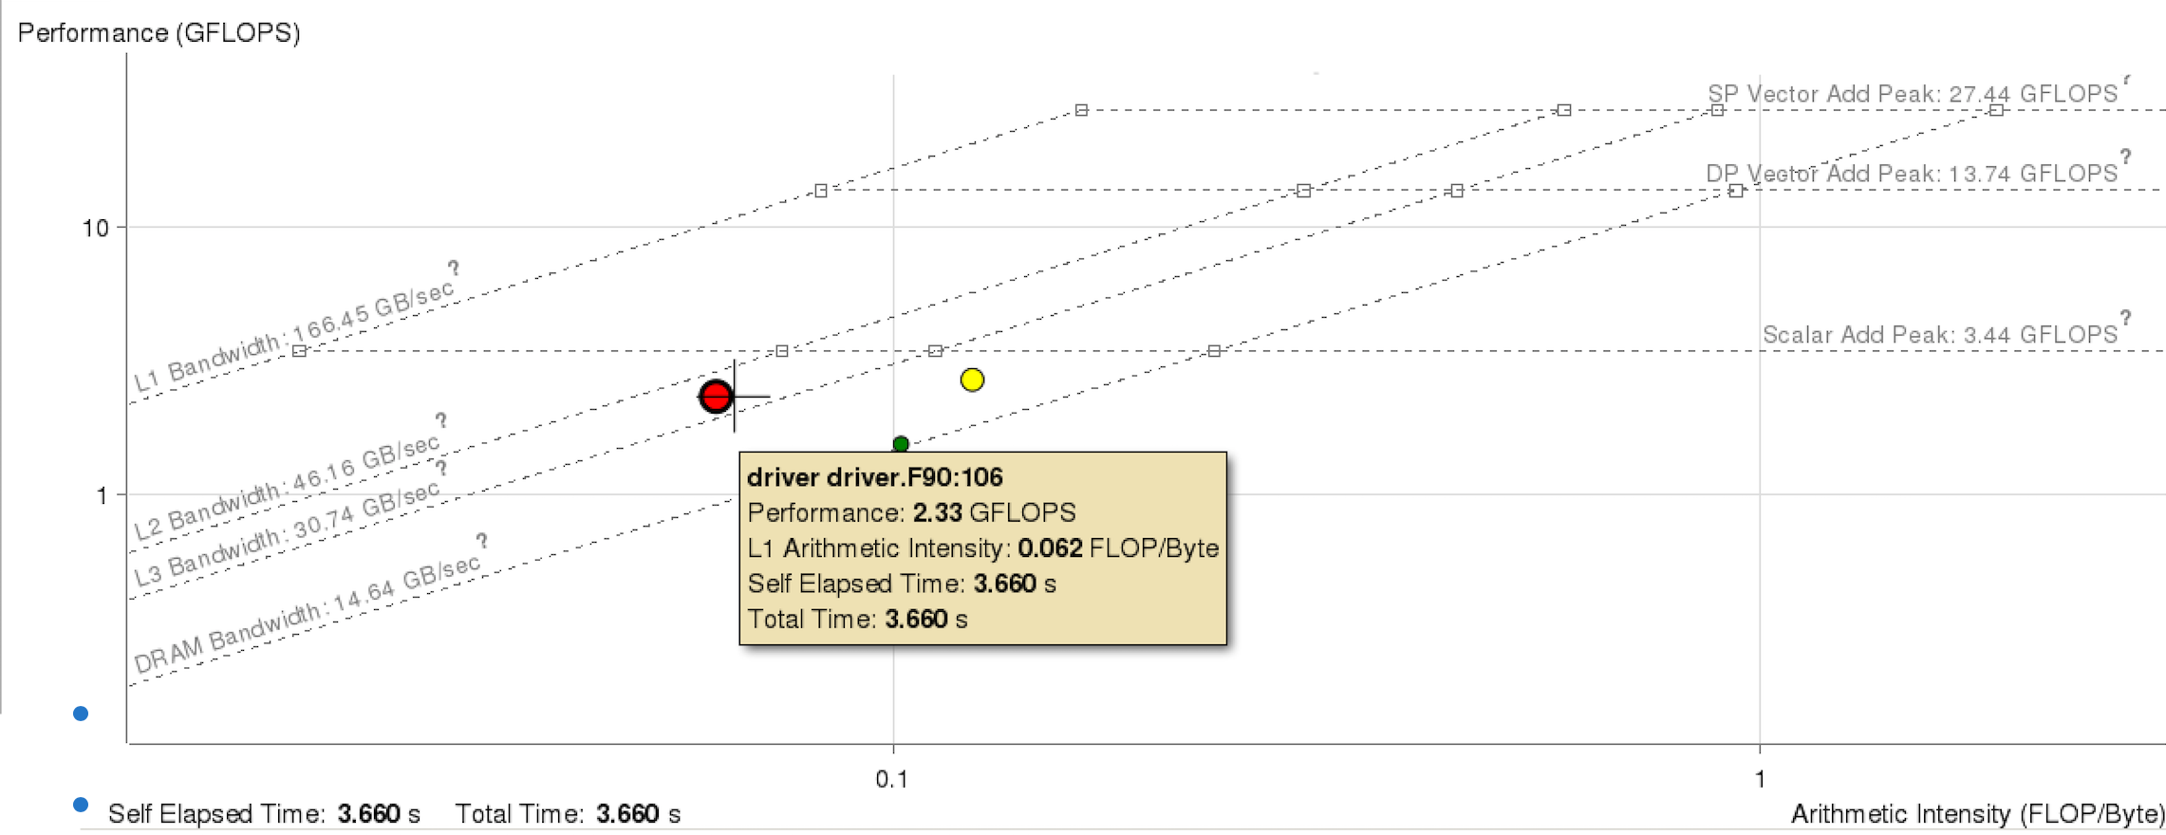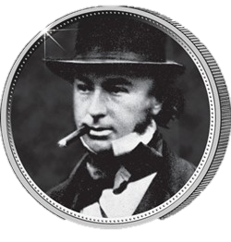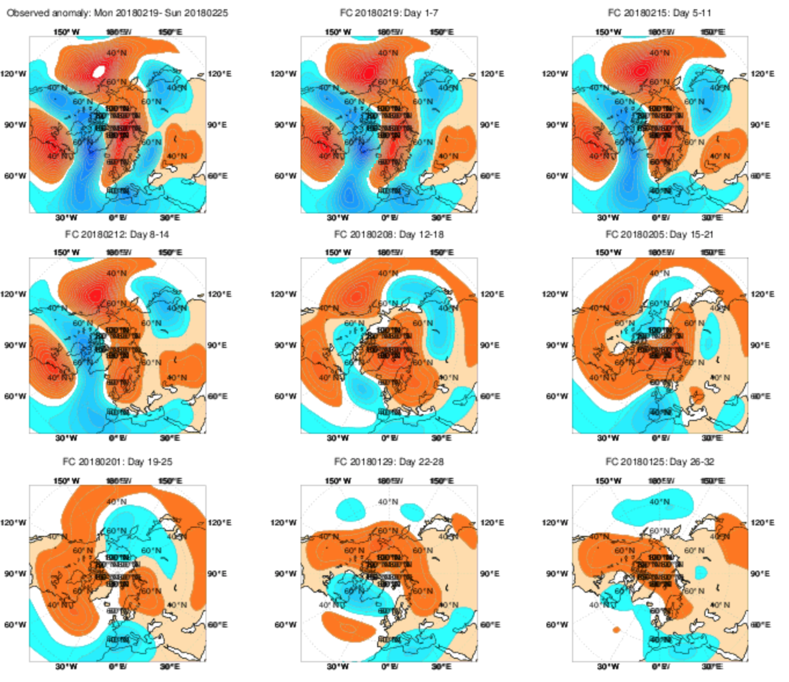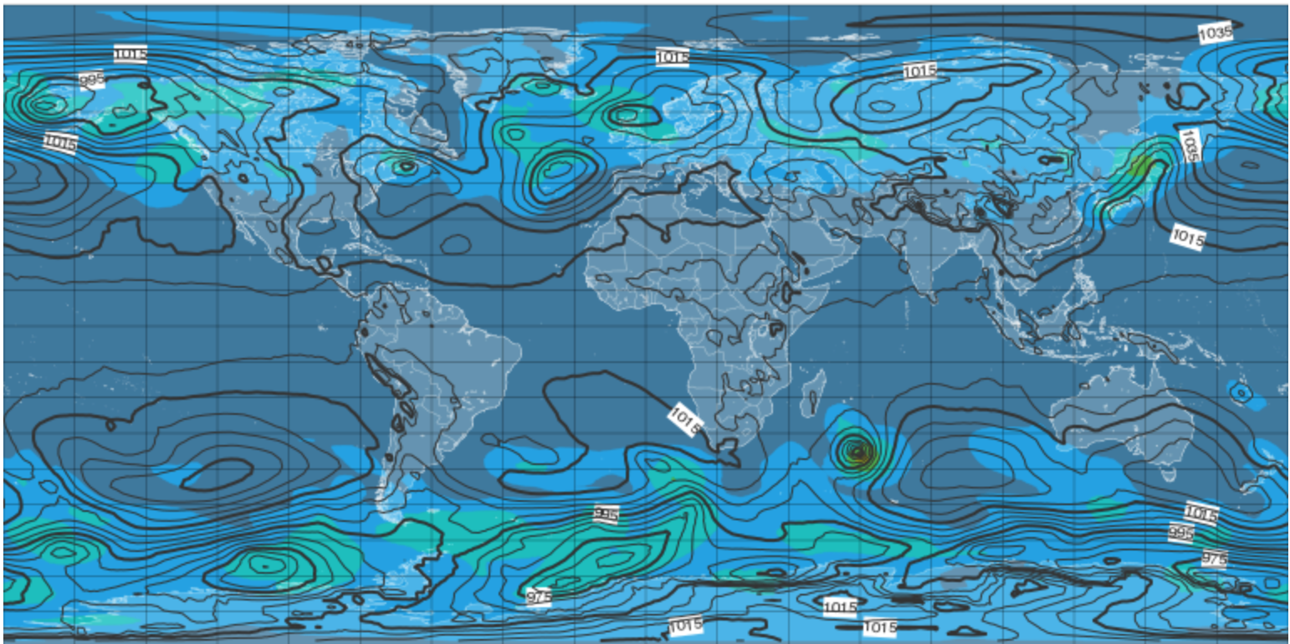

Weather Forecasting Performance Analysis on Isambard

Mihail-Calin Ionescu, supervised by Simon McIntosh Smith

University of Bristol, Department of Computer Science

|  |
| --- |
| Issues |
| * ARM nodes availability – offline for 3 week at the moment * Compilation issues on ARM when using the Cray and ARM HPC compilers |

|  |
| --- |
| Progress |
| * Obtained runtime analysis, roofline models for a subset of the ESCAPE dwarfs * Starting building OpenIFS on Isambard |

